**Data 512 – Part 1 – Common Analysis**

**Visualizations and Inference:**

**Question 1**

Produce a histogram showing the number of fires occurring every 50-mile distance from your assigned city up to the max specified distance.

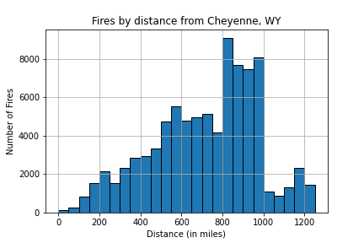

***Figure 1:*** *Fires By Distance from Cheyenne, WY*

Figure 1 illustrates the number of fires that are up to 1250 miles away from Cheyenne, WY. The largest number of fires occure 800-1000 miles away. However, there are an appreciably large number of fires 400 miles onwards as well. The entire state of Wyoming, and those around it are quite windy. Cheyenne is in fact the 5th windiest city in the US [1], with another city in Wyoming (Casper), cracking the top 10 as well.

Wind speeds in Cheyenne are about 12.9 miles per hour on average. Neighboring states like Colorado and Utah are also quite windy. It is possible that the strong winds may attribute to some of the smoke originating from distant fires compromising on the air quality in Cheyenne. That being said, one can make the argument that Cheyenne, and by extension even the state of Wyoming witnesses few forest fires, and based on the Air Quality Index (EPA), Cheyenne typically has good air quality, typically ranging from 18 to 35.

**Question 2:**

Produce a time series graph of total acres burned per year for the fires occurring in the specified distance from your city.

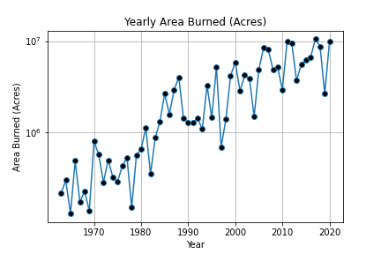

***Figure 2:*** *Area burned due to fires by year*

Figure 2 represents the area in acres burnt each year due to fires. The y-axis which represents the area is represented in the log scale for simpler comprehension of the data. On the chart, we see a linear trend in terms of the area that is burned, increasing over time. This means that the increase in area being burned is actually exponential considering the chart is in the logarithmic scale. This is quite a concerning phenomenon, and sends the signal that the US’ efforts towards curbing wildfires, saving the forest, and climate change are not as effective as they can be.

While only about 16% of Wyoming’s area is covered by forests, neighboring states like Utah, Colorado, Montana, Idaho, etc., have significant forest cover. From my response to question 1, distant fires seem to affect Cheyenne’s air quality. I believe that the forests in said neighboring states having significant problems with forest fires may be a contributing factor, further highlighting concenrs with the strength of national response to curtail such natural disasters.

**Question 3:**

Produce a time series graph containing your fire smoke estimate for your city and the AQI estimate for your city.

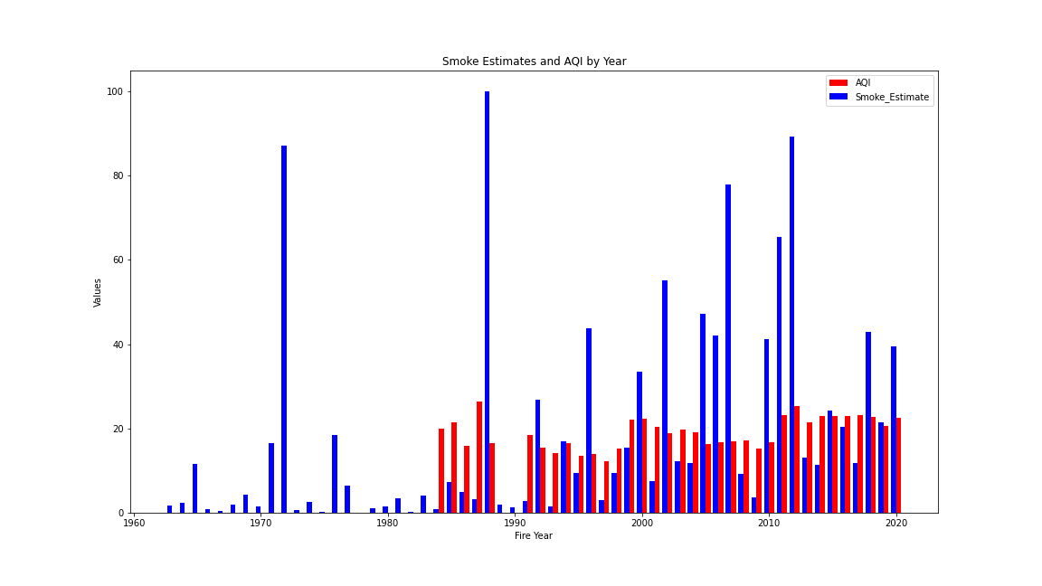

***Figure 3:*** *Smoke Estimates and AQI by Year*

Figure 3 presents the AQI values obtained via the EPA AQI API and the smoke estimates I calculated. I chose to use the fire season data as opposed to the data for the complete year, because I wanted to compare how the worst time for Cheyenne’s air quality compares with EPA’s assessment.

The EPA AQI values for Cheyenne were not available prior to 1984, with missing data for a few years after that too. However, the values have been consistently present since 1991. What I observe is that while there are some anomalies for some of my smoke estimates, the trend is fairly consistent otherwise. Some of these anomalies can be explained.

For example, the 1988 Yellowstone National Park was set ablaze due to a lightning strike, eventually burning through 1.2 million acres of the 2.2 million acres in the greater Yellowstone area [3]. Such fires occurring regularly in neighboring states at similar intervals led to my calculations sometimes being far off from the EPA AQI. Perhaps, the fact that I considered a distance of up to 1250 miles in my calculation contributed to large differences in certain points of time.

**Personal Reflection**

Over the course of this component towards the project, I engaged in discussion with my classmates, namely Raman SV, and Adithyaa V as we discussed the inferences we made for our respective cities that were assigned to us. We were concerned at how the new millennium coupled with the speeding up of ‘urban’ and industrial activities is intertwined with the exponential destruction of natural land and the inhabitants of this land. These environmental concerned are themselves intertwined – deforestation, air and water pollution, drought, global warming, etc.,

While the US government and NGOs champion sustainable development, reform and a sense of individual responsibility needs to be instilled – motivation to leave this world better than how we found it. Me, Adithyaa, and Raman hail from different parts of india and have explored various parts of the country. Some of the larger cities in India often have alarming AQI records, often going past 200. New Delhi, ranked the most polluted city until very recently had an AQI of 999[4] in 2015!

As globalization surges, so do our concerns with livability in the future. I have personally been invested with a wildfire detection project in the past where I worked with over 30 others around the world to deliver a machine learning model for embedded devices placed in forest regions that would alert the authorities in case of a forest fire ([Here](https://www.linkedin.com/posts/omdena_wildfire-wildfire-climatechange-activity-6957305005443796993-cU_i?utm_source=share&utm_medium=member_desktop) if you are interested 😊), and I wish to contribute to this space in a greater capacity in the future. This project seems like a great starting point for me to develop better domain knowledge.

**REFERENCES**

[1] Wyoming News, <https://www.wyomingnews.com/news/cheyenne-fifth-windiest-city-in-united-states/article_b333d0d8-a1c9-5d58-b963-e25b29664eb4.html>

[2] Wyoming forest area, <https://www.blm.gov/programs/natural-resources/forests-and-woodlands/forest-resilience/wyoming#:~:text=BLM%20Wyoming%20manages%20approximately%201.3,scenic%20landscapes%2C%20and%20economic%20opportunities>.

[3] Yellowstone Ablaze, <https://www.wyohistory.org/encyclopedia/yellowstone-ablaze-fires-1988>

[4] New Delhi air pollution, https://www.livemint.com/news/india/air-pollution-news-air-quality-in-delhi-worsens-aqi-in-anand-vihar-touches-999-top-10-updates-11699415617863.html